Press release

Mobile devices from ACD for use against Covid-19
Practical aids for maintaining minimum distances, also easy to clean and disinfect…
In the fight against the spread of Covid-19, ACD Elektronik GmbH supports companies in commerce, logistics and industries in making it easy to maintain the required minimum distance. In times marked by significantly stricter hygienic conditions, the M266SE Mobile Handheld Computer and MAX mobile workstation are the optimum solution. Both products are very easy to clean and disinfect, which makes them ideal for use in times of a pandemic.
MAX mobile workstation – flexible and suitable for use with distancing
For nearly 15 years, the MAX mobile workstation from ACD has stood for independent and flexible work in all warehouse environments - a feature with even more value in today's times. With the MAX mobile workstation it is easy to maintain the required minimum distance of six feet in the warehouse: Social distancing without losing capacity or creating production bottlenecks, since each employee is able to go about his/her activity independently and without using any shared stationary workstations. In addition to independent working with distancing, another advantage of the MAX mobile workstation is that it can be cleaned effectively. The smooth steel surfaces of the MAX can be cleaned and disinfected quickly and easily at the end of a shift or when another employee uses the MAX. Since the MAX mobile workstation is based on a modular system, additional protective walls can be mounted on the sides if necessary.
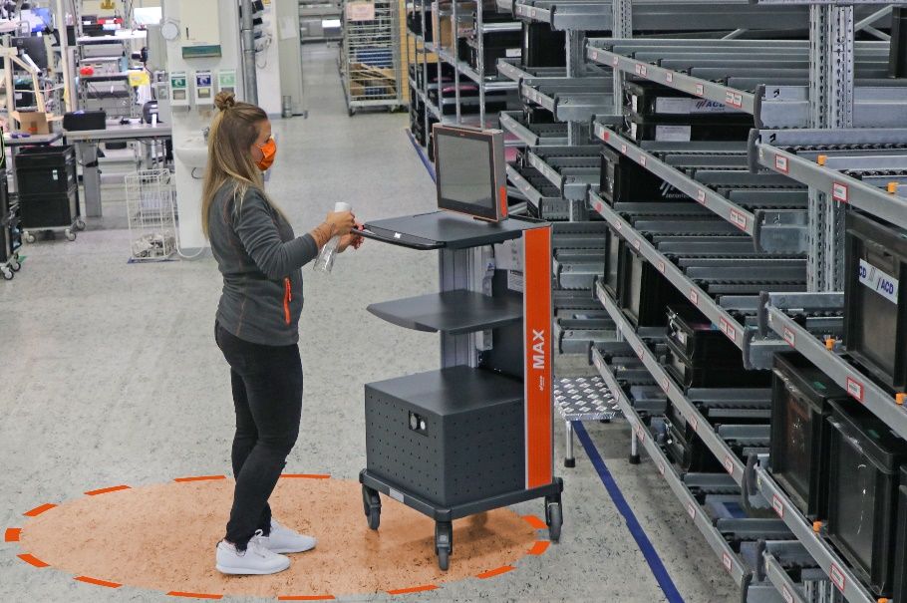
Photo: MAX mobile workstation makes it easy to maintain minimum distance

M266SE – a Mobile Handheld Computer for especially strict hygienic conditions
For a long time now, the M266SE Mobile Handheld Computer has provided a solution to the problems of material tracking and batch tracing in sensitive production areas such as the food or pharmaceutical industry. The M266SE is the only handheld of its kind to meet the strict hygienic requirements of these industry sectors, and this now proves beneficial in other industries as well. The M266SE has a washable membrane keyboard, if needed with antimicrobial coating, and a matching housing with protection rating IP65 (protection against dust and splashed water). Due to the materials selected, the Mobile Handheld Computer is naturally resistant to commonly used cleaning and disinfecting agents (such as RD antiseptic, Hydrogen Peroxide, and isopropanol). The absence of edges, uneven areas and depressions where dirt accumulates help make it easy to clean and disinfect efficiently.

Photo: Effective cleaning and disinfecting with the M266SE Mobile Handheld Computer

The M266SE Mobile Handheld Computer and MAX mobile workstation make it enormously easier to work under difficult circumstances, ensuring distancing requirements and working at the usual level of efficiency – plus easy cleaning and disinfecting. Process optimization and employee protection are always the highest priorities for German manufactured hardware – not just in times of fighting a pandemic.

Additional information:
ACD USA Inc., Chris Gould
1001 Mittel Drive, Wood Dale, IL 60191
Tel.: 224-507-1441
Christopher.Gould@acd-group.com
www.acd-group.com

ACD Group
ACD USA Inc. is part of the owner-managed ACD group of companies, one of the leading high-tech providers in the electronics sector. ACD USA Inc. provides hardware and software solutions for mobile devices and applications used in retail business, logistics and industry. Today the ACD Group has locations in Germany, the Czech Republic and the USA. The Group has a total of over 420 employees and generated annual sales of about 85 million euros in 2019.

